YMGuide Installer

# Previous Installer interface

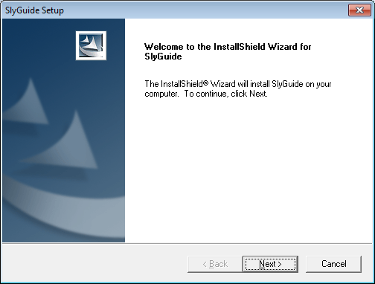

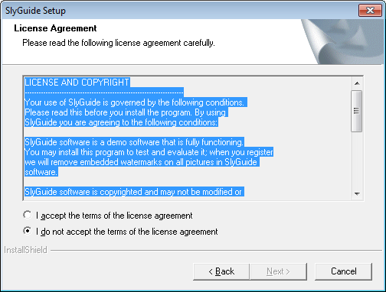

LICENSE AND COPYRIGHT

---------------------------------------------------------------------

Your use of YMGuide is governed by the following conditions.

Please read this before you install the program. By using

YMGuide you are agreeing to the following conditions:

YMGuide software is a demo software that is fully functioning.

You may install this program to test and evaluate it; when you register

we will remove embedded watermarks on all pictures in YMGuide

software.

YMGuide software is copyrighted and may not be modified or

included with another product without the express, written

permission of Sly Multimedia. You may not decompile, disassemble

or otherwise reverse engineer this product. Your use of YMGuide

is at your own risk. Sly Multimedia shall not be held liable for

consequential, special, indirect or other similar damages or claims,

including loss of profits or any other commercial damages. Sly

Multimedia specifically disclaims all other warranties, expressed or

implied, including but not limited to implied warranties of

merchantibility and fitness to a particular purpose.

Your use of this software constitutes your acknowledgement and

acceptance of these conditions.

---------------------------------------------------------------------

Copyright (c) 2003-2004, Sly Multimedia. All Rights Reserved.

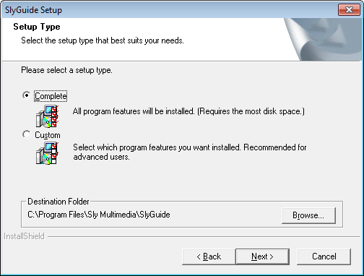

* Custom

